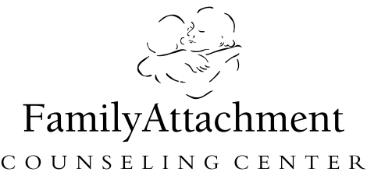

Parents of Adopted Children Group
Topic: The Nurtured Heart Approach and other Discipline Techniques

Facilitator: Dr. Joanne May, PhD, LP
Cost: $90 for individual; $125 for a couple

Dates
July 10
July 17
July 24
July 31
August 7
August 14
Group meets from 10-11:30 am each day

Location
Family Attachment Center
18322C Minnetonka Blvd. Questions:
Deephaven, MN 55391 Todd@familyattachment.com or 952-475-2818 ext. 4

4 Ways to Register Registration Information
 Call Todd at 952-475-2818, (ext. 4)   E-mail todd@familyattachment.com   Mail completed form to Family Attachment Center  18322C Minnetonka Blvd., Deephaven, MN 55391   Fax completed form to 952-475-3356  Payment Information Amount: _____________  Method: □ MasterCard □ Visa □ Check enclosed  __________________________________________  Credit Card Number Exp. date  __________________________________________  Billing address  __________________________________________  Name on Card Signature | □ $90 One Registrant □ $125 Two Registrants  ___________________________________________  Name(s)  _______________________________________________  Organization  _______________________________________________  Address  _______________________________________________  City State Zip  _______________________________________________  Phone Fax or e-mail for confirmation  Refund Policy: Refunds, minus a $25 fee, are available up to 7 days prior to the start. No refunds available after that time.

